

Scholarship Application Tips
Deadline April 17!

- Start early
  - Read the application in advance to understand what’s required and the deadline for applying.
    - Decide whom to ask for letters of recommendation; give them at least two weeks to get the letters back to you.
      - CCF’s general application requires two current letters from people who are not related to you, only one of which can come from a school faculty member.
    - Request any needed transcripts or other supporting materials well in advance.
- Follow the requested format and provide all the requested information.
  - Incomplete applications might not be considered at all.
      - The CCF scholarship applications use Google Forms. Attachments must be in PDF format.
      - When we receive your application, we try to check that everything is there, but there are no guarantees! We might miss something. If we do reach out to ask you for missing information, reply promptly and within the requested time period.
- Most scholarship applications require essays. These are very important, and they are carefully considered by Scholarship Award Committees.
  - Stick to the requested topic.
  - If there are multiple essays, don’t use the same idea over and over again. Take the opportunity to tell the Scholarship Award Committee something new about yourself.
  - It’s okay to get help with grammar, spelling, and making any word or character counts – but do your own writing. The Scholarship Award Committee wants to hear from you personally, in your own words, in your own unique communication style.
      - The CCF general application has two required short essays. You may be asked to provide other essays depending on the scholarships you are eligible for. Our Bootstrap scholarship application for working students requires one essay.
- Make sure to provide any requested current contact information. Check your email regularly after submitting your scholarship applications.
      - CCF uses email as the primary method of communication with scholarship applicants and recipients. We ask for an email address that will remain active for the next 12 months.
- Ask questions!
  - If you have any questions about the application, format, or submission process, just ask! Many scholarship providers welcome questions and want you to succeed in completing their applications.
      - Our email address is info@crookcountyfoundation.org. Please reach out if you have questions.

CCF’s General Scholarship Application has two required essays.
- Please write a short essay describing your specific educational plans and career goals, and why? What motivates you to achieve them? (1,500 character limit)
- Describe a significant change, experience, or accomplishment in your life. How has that shaped you? What did you learn about yourself? (1,500 character limit)

It also includes Scholarship Eligibility Checklists. These checklists help us understand your eligibility for specific scholarships administered by the Crook County Foundation. We recommend that you review all applicable criteria and complete any additional sections of the application. You should still submit an application even if you don’t check any of these boxes!

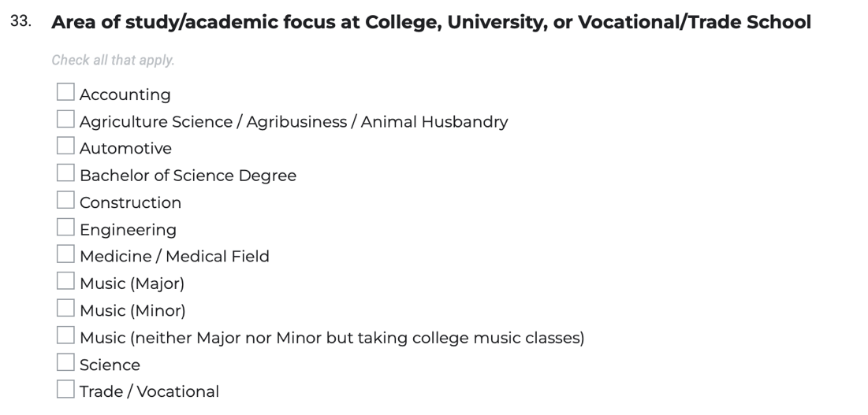

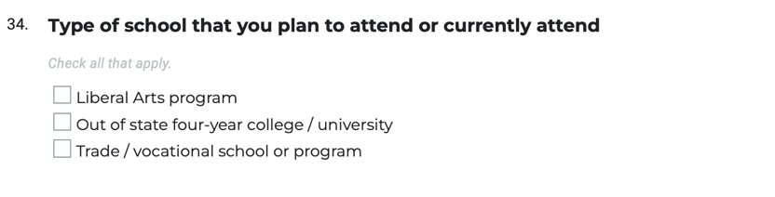

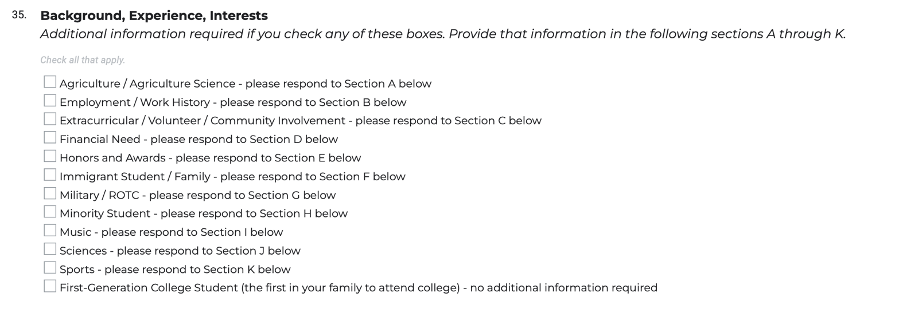
CCF’s Bootstrap Scholarship Application for working students has one required essay.
- Please write an essay telling us who you are, where you want to be in five years, and how you intend to get there. Explain how getting this scholarship award will help you achieve your objectives. (3,000 character limit)

(March 2026)

